ANALYSTLAB AFRICA
HEALTHCONNECT CLINIC EXPERIENCE LAB
WEEK 7 DATA ANALYTICS TESTING & REFINEMENT REPORT
Track: Data Analytics
Summary
Week 7 focused on testing, refinement and validation of my Data Analytics outputs developed during Week 6 assignment. The same HealthConnect appointment dataset was retained, and the existing Power BI dashboard was treated as the starting point rather than rebuilding the project. The main testing areas were KPI accuracy, consistency between dashboard values and the underlying dataset, dashboard filters and calculations, and the continued validity and usefulness of important attendance and no-show findings.
Week 6 to Week 7 Transition
- Main Week 6 output: An Advanced Decision Support Power BI dashboard for the HealthConnect appointment dataset.
- Most important Week 6 component: Analysis of appointment attendance and no-show patterns using booking lead time, previous no-shows, reminders, distance to clinic and combined risk segments.
- Main limitation: The analysis showed associations within the dataset but did not establish causation. The planned Data Science cross-track validation was not completed because a Data Scientist was not available.
- Component requiring testing: The Week 6 KPIs, no-show findings, risk-segment analysis, dashboard calculations, visuals and filters.
- Testing objective: Determine whether the analytical outputs are accurate, consistent with the underlying dataset, stable across relevant segments and clearly communicated.
- Expected improvement: Correct any calculation, interpretation, filter, visualization or usability weakness identified during testing and then re-test the affected output.

KPI Testing
Validating Total appointment value and formula 2. Validating total no shows KPI 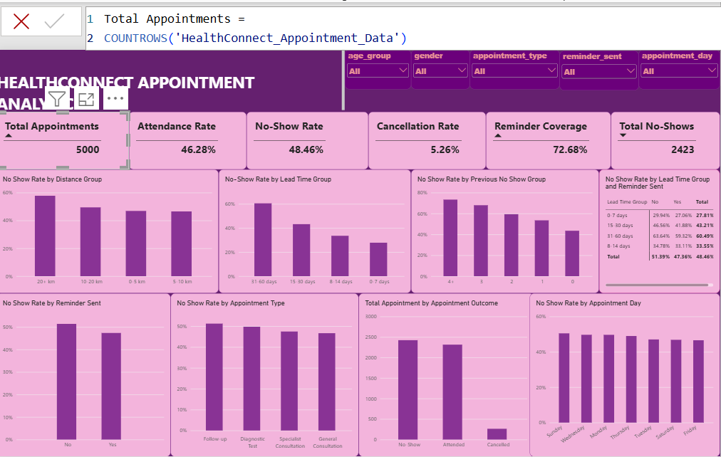 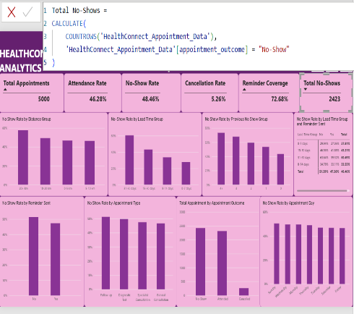
All the KPIs in week 6 dashboard passed the validation tests.
Filter testing
Week 6 power BI KPI values and visualizations before filter testing.
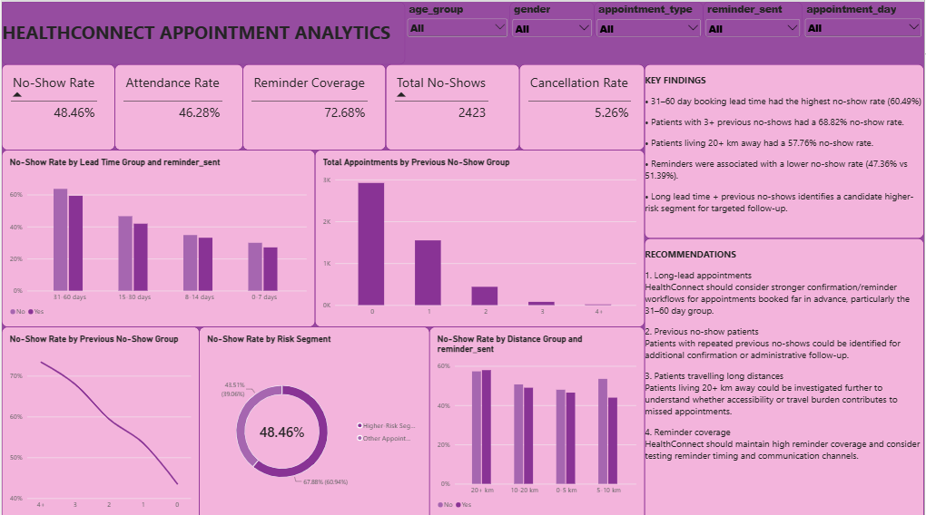

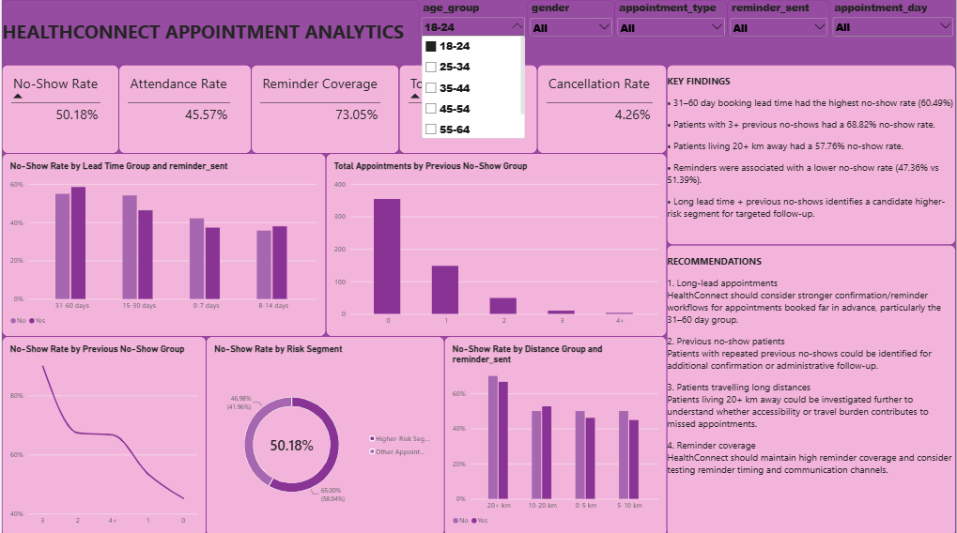
The dashboard responded to the age group filter after selecting 18 to24 years and recalculated the connected visuals.
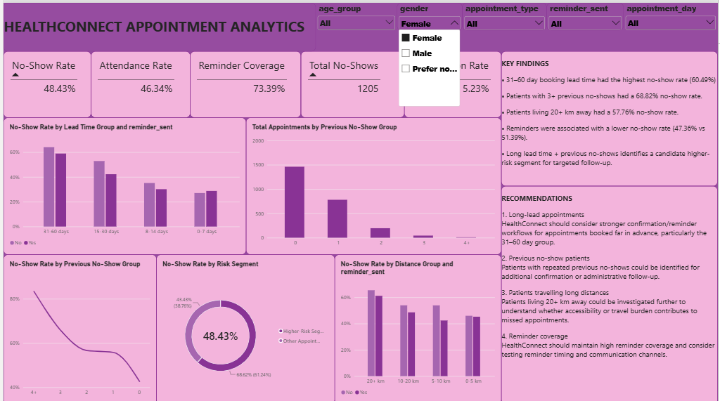
Dashboard response after selecting female in the gender slicer
All the charts and KPIs responded during filtering test using the different slicers on the week 6 power BI dashboard.

Testing Visual Interactions
Testing no show rate by reminder sent chart
Reminder Status | No-show Rate
Reminder Sent | 47.36%
No Reminder | 51.39%

Testing the same chart with gender slicer selecting female.
Reminder Status | No-show Rate
Reminder Sent | 46.82%
No Reminder | 52.87%

The chart responded to the female gender filter and recalculated the displayed values.
UPDATED FINDINGS
- The HealthConnect dataset contains 5,000 appointments, with the Week 6 baseline showing an attendance rate of 46.28%.
- The Week 6 baseline showed a no-show rate of 48.46%, representing 2,423 no show appointments.
- Reminder coverage was 72.68%.
- Week 6 analysis examined the following risk factors previous no-shows, booking lead time, reminders, distance and waiting time as factors associated with attendance outcomes.
- The Week 7 testing process was used to determine whether the important dashboard outputs and findings remained consistent under relevant filters and after dashboard refinement.
UPDATED RECOMMENDATIONS
- Continue monitoring no-show rates as a key operational KPI.
- Monitor patients with previous no-show history as an important risk segment
- Continue monitoring reminder coverage and its association with attendance outcome
- Use dashboard filtering to examine attendance patterns across relevant patient and appointment segments.

CROSS-TRACK TESTING
A Data Science cross track validation activity could not be completed because a Data Science collaborator was not available during the Week 7 testing period.
Week 8 priorities
- Continue monitoring validated KPIs.
- Complete the outstanding cross-track validation with a data science intern.
- Maintain dashboard usability and consistency.
- Incorporate new evidence or feedback.
- Prepare the final HealthConnect solution for submission.
Week 7 Conclusion

Week 7 advances the HealthConnect Data Analytics work from development and integration into systematic testing and refinement. The same appointment dataset and Week 6 dashboard are retained, while the analytical outputs are subjected to KPI validation, dashboard testing, finding reassessment and refinement. The result is intended to provide a more reliable and clearly communicated analytical foundation for HealthConnect's final integration in Week 8.

